Projet tracés cour élémentaire

[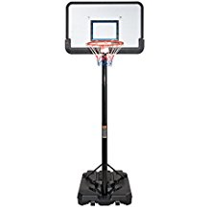](https://www.google.fr/url?sa=i&rct=j&q=&esrc=s&source=images&cd=&cad=rja&uact=8&ved=0ahUKEwjZ64yP6oHYAhVQLVAKHXjAC4gQjRwIBw&url=https://www.amazon.fr/panier-de-basket-pied-3m05/s?ie%3DUTF8%26page%3D1%26rh%3Di:aps,k:panier%20de%20basket%20sur%20pied%203m05&psig=AOvVaw3bstSoxQsTBDEZuU5vs-re&ust=1513077235484854)

[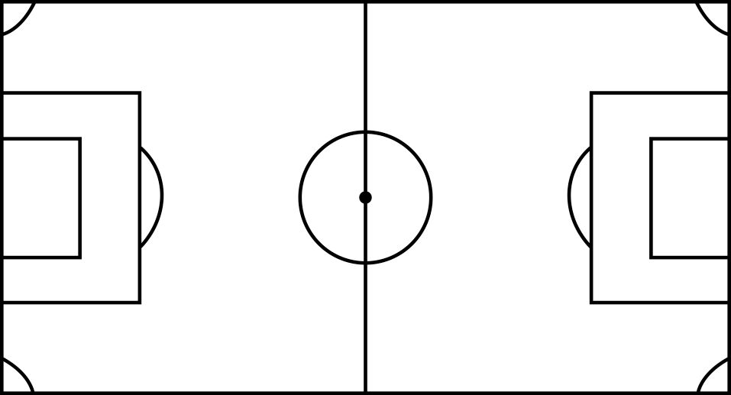](https://www.google.fr/url?sa=i&rct=j&q=&esrc=s&source=images&cd=&cad=rja&uact=8&ved=0ahUKEwi1lKDJ6YHYAhVQbVAKHW1LBYsQjRwIBw&url=http://dessinsetcoloriages.blogspot.com/2016/06/page-de-coloriage-grand-format-imprimer_12.html&psig=AOvVaw3FYc_lJKI9xQyjuLcBwsck&ust=1513077091918106)